CLASS XII TOPPERS IN SCIENCE STREAM-2022

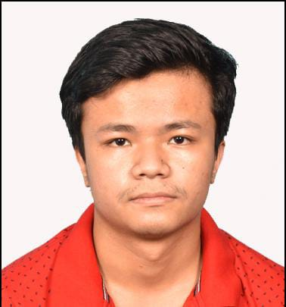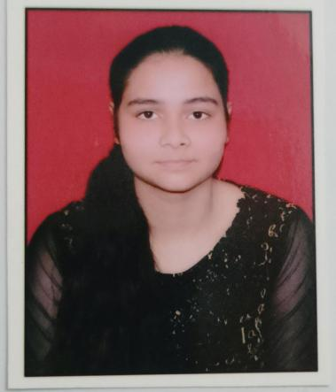
HEMANT SINGH KUMARI SALONI
95.6% 92.6%

SUDHANSHU SHARMA 91.0%

TOPPERS IN COMMERCE STREAM CLASS XII -2022
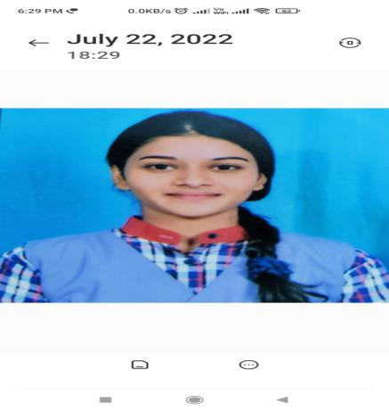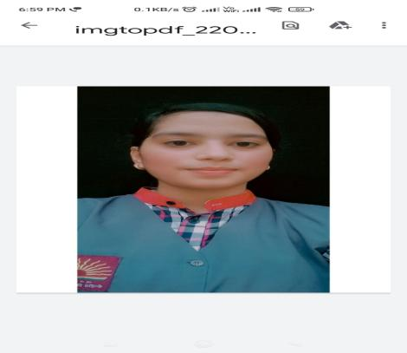
NEHA CHAUHAN NIDA KHAN
89.0% 84.8%
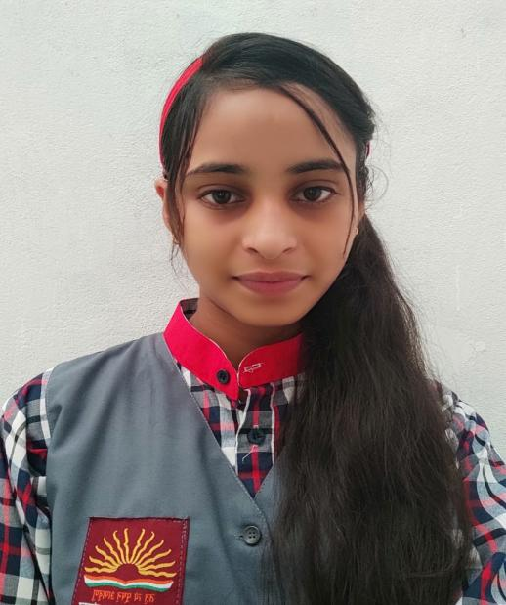
UMRA FATIMA 84.2%

TOPPERS IN HUMANITIES CLASS XII -2022

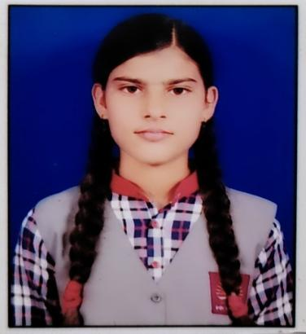
ZAHEER KHAN SHAKSHI SINGH
94.2% 91.4%

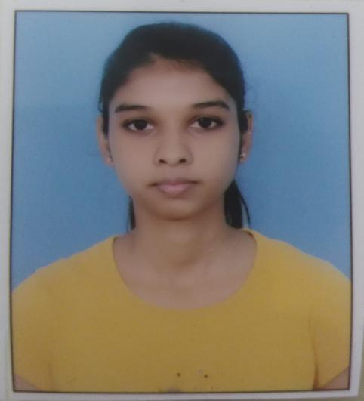
VANSHIKA SINGH 90.2%

TOPPERS IN CLASS X -2022

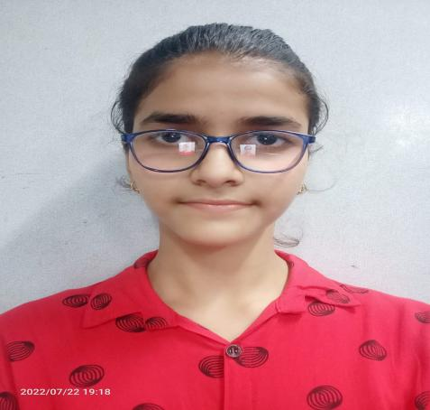
APRAJITA KUMARI SALEENA 96.8% 96.8%
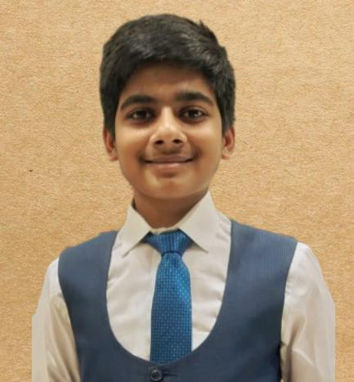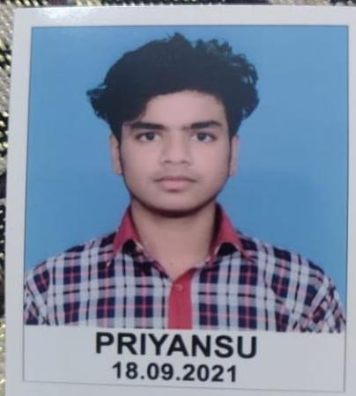
ABHISHEK SINGH PRIYANSHU
96.8 % 95.2%

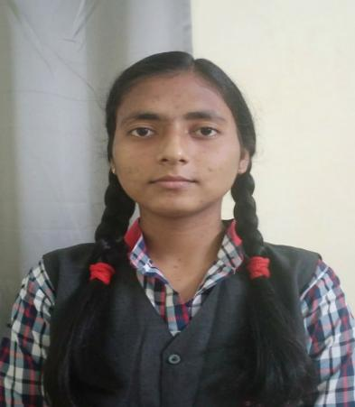
AYUSHI YADAV
95.0%

